|  |  |  |
| --- | --- | --- |
| **Lyng Primary School P.E Knowledge Organiser** | | |
| **Topic: Invasion Games** | Year 2 | Autumn 1 |

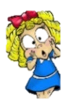



|  |  |
| --- | --- |
| **Key words** | |
| **Spelling** | **Definition** |
| Catching | Seize a moving object with your hands. |
| Hitting | Striking an object with force |
| Jumping | Bend your [knees](https://www.collinsdictionary.com/dictionary/english/knee), [push](https://www.collinsdictionary.com/dictionary/english/push) against the ground with your feet, and move quickly [upwards](https://www.collinsdictionary.com/dictionary/english/upwards) into the air. |
| Kicking | Hit an object with your foot so that it moves through the air. |
| Opponent | The person who is playing against you. |
| Rolling | Move on a surface while lying down, turning your body over and over. |
| Running | Running in a race means running in completion with others. |
| Tactics | [Methods](https://www.collinsdictionary.com/dictionary/english/method) that you [choose](https://www.collinsdictionary.com/dictionary/english/choose) to use in order to [achieve](https://www.collinsdictionary.com/dictionary/english/achieve) what you [want](https://www.collinsdictionary.com/dictionary/english/want) in a particular [situation](https://www.collinsdictionary.com/dictionary/english/situation). |
| Team Mate | The other members of your team. |

**Unit Objectives**

• What is an opponent and team mate?.

• Can I use rolling, hitting, running, jumping, catching and kicking skills in combination?

• How do I use tactics?

• Do I need to lead others?

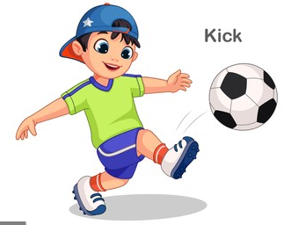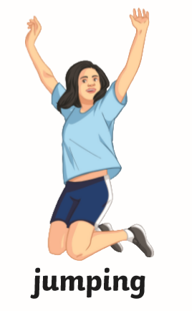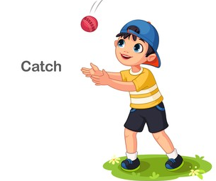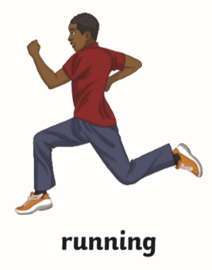

**“Enjoy the game and chase your dreams. Dreams do come true!”**

**Sachin Tendulkar**

**“Self-belief and hard work will always earn you success” – Virat Kohli**

|  |  |  |
| --- | --- | --- |
| **Lyng Primary School P.E Knowledge Organiser** | | |
| **Topic: Invasion Games** | Year 2 | Autumn 1 |

|  |  |
| --- | --- |
| 1. What should you do before you start exercising? |  |
| Stretch so you are ready |  |
| Sit down and rest as much as possible |  |
| Run around quickly so your heart beat is fast. |  |

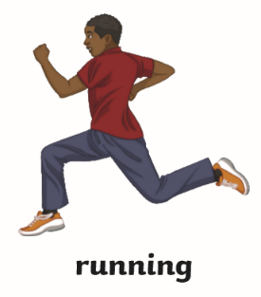

Name of skill: __________________________



Name of skill: __________________________

|  |  |
| --- | --- |
| 1. What should you do before you start exercising? |  |
| Stretch so you are ready |  |
| Sit down and rest as much as possible |  |
| Run around quickly so your heart beat is fast. |  |

|  |  |
| --- | --- |
| 1. What does opponent mean? |  |
| The other people on your team |  |
| Your favourite team. |  |
| The people who are playing against |  |



Name of skill: __________________________